**Periodic Table Group**

Nicolas Martin, Joshua Filer, Jordan Geddes, Vy Dinh

**3D Periodic Table**

**User Guide & Test Plan**

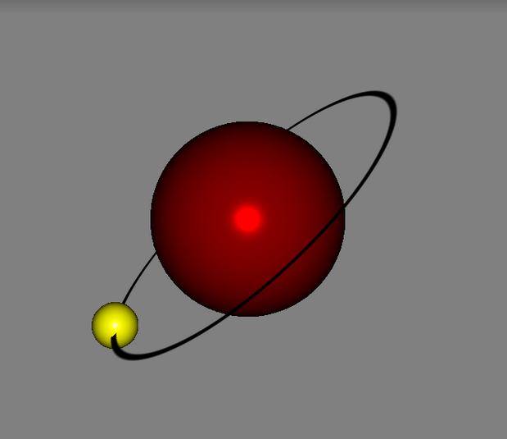

Table of Contents

**Table of Contents1**

User Guide2

Test Plan5

**Test Case6**

**User Guide**

1. Getting started
   1. Ensure you have all these files saved on your machine in a specified location:
      1. Element.java
      2. Model.java
      3. PeriodicTable.java
      4. TableGui.java
      5. Xform.java
      6. Find and download all of these files at: https://github.com/jgeddes101/periodic-table/tree/master/periodictable
   2. In Command Prompt, set the file location to compile your program, compile the Program file: PeriodicTable.java with the Javac compiler and then run the program through the Java virtual machine.
2. How to use
3. After you Compile and run the program on Command Prompt, an interactive periodic table as below should appear.
4. 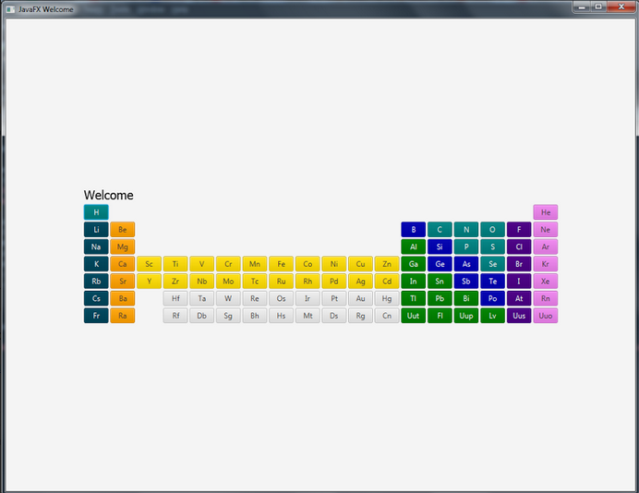This table has information for all 109 elements. When you click on any button, an information menu will pop-up displaying information of that element. Test this display by clicking on button “H” for the element Hydrogen or any other element of your choice.
5. The specification screen has a button that opens the window showing the model in 3D which can be rotated using the mouse. Once you have viewed the specifications of this model, click the button “Display Model” to view the 3D model of the atom. Clicking the X at the top of the screen should terminate the window and send you back to the main table menu.

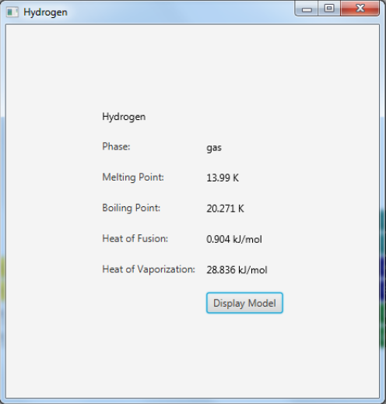

1. The 3D model will be displayed as shown below. Note, each element atom is different with the number of protons, neutrons, and electrons. Note the different colors for the nucleus, protons, electrons, and neutrons. Electrons represent Yellow, Protons represent red, and Neutrons represent blue. Use the mouse to scroll around the atom to see it at different angles.



1. Once you are satisfied with displaying the 3D model, click the close X and the program will send you back to the spec view, followed by closing that page and returning to the periodic table menu.
2. Repeat steps a-e as many times as you desire. Once you feel that you’re done with the program, press the Close X at the top of the GUI window to terminate the program.

**Test Plan**

**Test Case**

|  |  |  |
| --- | --- | --- |
| Test Case ID | 01 | |
| Test Name | Hydrogen Atom View Test | |
| Description | The user selects the Hydrogen element and displays the specs and 3D Model along with rotating the 3D model to view it at different views with the mouse | |
| Prerequisites | Must have Java Virtual Machine and all APIs essential to operate program. Must have some knowledge of identifying parts of an atom and its features such as protons, neutrons, and electrons. | |
| Test Environment | At the user’s personal home  computer(either Windows or Mac) | |
| Test Strategy |  | |
|  |  |  |
| Open the Periodic Table | | |
| Step | Input Description | Expected Output |
| 1 | Open Program | Program should launch and open to the Periodic Table displaying buttons for you to select |
| 2 | Select "H" on the table | The GUI should now be a new screen that has information of the element Hydrogen with a button to display 3D model. |
| 3 | Select “Display Model” in Hydrogen information screen | The 3D model view should appear showing the atom model of the Hydrogen. The user should also be able to rotate and see the atom model at different views while scrolling with the mouse. |
| 3 | Click X on 3D model screen | The screen of 3D model should be closed. This will return the user to the Information view of the element. |
| 4 | Click X on information screen | The screen of element spec information should be closed. This will return the user to the Periodic Table view. |
| 5 | Click X on the table | The table should be closed, terminating the program. |